
Taibah University
College of Computer Science and Engineering
Department of Information Systems

Detection of AI-Generated Arabic Text: A Data Mining Approach
Submitted by: Shoag Khaleel Almodifer
Supervised by: Prof.Mohammed Al-sarem

Student ID:4725067

1st Semester 2025-2026
MSIS-822 Advanced Data Analytic Techniques

Abstract
This project presents a complete framework for detecting AI-generated Arabic text using machine learning and deep learning approaches. The Arabic Machine-Generated Text dataset which was derived from The Arabic AI Fingerprint study, was preprocessed through extensive cleaning, normalization, and lemmatization steps to ensure high linguistic quality. Both lexical-based features (TF-IDF) and contextual embeddings (BERT) were extracted and used to train multiple models that includes Logistic Regression, SVM, Random Forest, XGBoost, and Feedforward Neural Networks. The experimental results showed that XGBoost with TF-IDF features has achieved the best performance, with an accuracy of 95.1% and an F1 score of 0.950. This confirms that traditional models work well for structured textual features. At the same time, BERT embeddings improved generalization in neural architectures. The findings demonstrate clear stylistic and statistical differences between human-written and AI-generated Arabic abstracts and support the development of reliable Arabic AI-text detection tools.

Introduction
The rise in using large language models (LLMs) has made it more difficult to distinguish between human-written and machine-generated text. There is a lot of research for English, Arabic detection remains limited due to the language’s morphological richness, diverse dialects, and lack of annotated data. Detecting AI-generated Arabic text is crucial in order to maintain academic integrity, combating misinformation, and to ensure content authenticity across digital platforms.
The goal of this project is to design and evaluate an Arabic text-classification pipeline capable of identifying whether a text is written by a human or by an AI model. It combines stylometric analysis along with machine-learning and deep-learning algorithms, comparing classical lexical representations (TF-IDF) and modern contextual embeddings (BERT). The study also examines linguistic indicators—such as redundancy, short-word ratio, sentence length, and vocabulary richness—to highlight measurable stylistic differences between human and AI writing styles. Through this framework, the project contributes to advancing Arabic NLP research and developing practical tools for AI-text detection.

Related Work

The Arabic AI Fingerprint: Stylometric Analysis and Detection of Large Language Models Text [1]. The paper “The Arabic AI Fingerprint” (2025) analyzes Arabic texts generated by models like ALLaM, Jais, LLaMA, and GPT-4. It shows clear linguistic patterns such as lower lexical diversity. BERT-based detectors achieved to 99.9% F1-score in academic settings but struggled across domains. The dataset from that study forms the basis for this project’s experiments in Arabic AI-text detection and stylometric analysis.

Human vs. Machine: A Comparative Study on the Detection of AI-Generated Content [2]. The study focuses on detecting LLM-generated (DeepFake) text using transfer learning on pre-trained models, achieving 94–99% accuracy, which is better than human detection. It emphasizes the need for automated authenticity checks and aligns with this project’s goal of distinguishing human-written and AI-generated Arabic text through stylometric and deep-learning methods.

ALHD: A Large-Scale and Multigenre Benchmark Dataset for Arabic LLM-Generated Text Detection [3]. The ALHD dataset is a large Arabic corpus (400K+ samples) distinguishing human and LLM-generated texts across news, social media, and reviews in both MSA and dialects. Fine-tuned BERT models outperformed larger LLMs but struggled with cross-genre generalization. Like this project, it advances Arabic AI-text detection—though this work focuses specifically on academic abstracts using stylometric analysis.

Dataset Description
The Arabic Machine-Generated Text Dataset is a specialized corpus designed to support research on detecting and analyzing Arabic texts generated by Large Language Models (LLMs). It was introduced in the study “The Arabic AI Fingerprint: Stylometric Analysis and Detection of Large Language Models Text” [1]. The dataset aims to enable stylometric analysis, cross-model generalization, and the development of Arabic AI-text detection systems.
The dataset contains 8,388 samples of Arabic academic abstracts produced through three main generation methods:
- by_polishing – refining existing human abstracts (2,851 samples),
- from_title – generating abstracts from titles only (2,963 samples), and
- from_title_and_content – generating text using both title and paper content (2,574 samples).
Each entry includes a human-written abstract (original_abstract) and corresponding AI-generated versions from several models: ALLaM (7B), Jais (70B), Llama 3.1 (70B), and OpenAI GPT-4. The dataset focuses on Modern Standard Arabic (MSA) academic abstracts collected out from the Algerian Scientific Journals Platform (ASJP), covering publications from 2010 to 2022 to ensure data authenticity from the pre-AI era. Human abstracts average around 120 words, while generated ones vary between 62–165 words, depending on the model and generation method.
Data were collected and processed using automated web scraping and text extraction out from PDFs. Metadata (titles, journals, publication dates, abstracts) were extracted, and multilingual abstracts were segmented using rule-based and statistical methods. Preprocessing included Unicode normalization, removal of formatting artifacts, and filtering of low-quality or incomplete texts. Scripts and some processing tools are available at https://github.com/KFUPM-JRCAI/arabs-dataset.
From the research findings, LLM-generated texts exhibited lower vocabulary diversity and distinct frequency patterns, forming identifiable linguistic fingerprints for each model. The dataset supported detection models that achieved up to 99.9% F1-score, with strong cross-model generalization (86–99.9%) and near-perfect precision in identifying AI-generated content.

Methodology

Data Preparation and Preprocessing
The Arabic textual data were collected, cleaned, and standardized throughout a comprehensive Python pipeline. This stage included removing duplicates, handling missing data, normalizing Arabic characters, removing diacritics, and applying stopword removal and lemmatization.
Multiple cleaning modes were implemented,basic preprocessing, advanced normalization, and lemmatization to ensure data consistency and preserve semantic meaning.

Feature Engineering
Several linguistic and structural features were extracted to enrich the dataset and improve classification accuracy. These include:
- Short Word Ratio (N): proportion of short words (≤3 letters) in each text.
- Total Number of Lines (L): to count the number of text lines.
- Number of Foreign Letters: to measure non-Arabic character frequency.
- Number of Active Voice Sentences: detected using dependency parsing in Stanza.
- Redundancy Score: to evaluate textual repetition using TF-IDF weights.
These features provided quantitative insights into text complexity, linguistic diversity, and stylistic patterns.

Modeling
A set of machine learning and deep learning algorithms was implemented to classify Arabic texts into their respective categories.
Models were organized as follows:
- Baseline Models: Logistic Regression and Naïve Bayes.
- Traditional ML Models: Support Vector Machine (SVM), Random Forest, and XGBoost.
- Deep Learning Models: Feedforward Neural Network (FFNN) and a Simple DNN.
Each model was trained using both TF-IDF and BERT embeddings to compare lexical-based versus context-aware representations. All models were trained on the training split, tuned on validation, and evaluated on a held-out test set by using Accuracy, Precision, Recall, F1-score, and ROC-AUC metrics.

Results & Analysis

Data Cleaning and Preprocessing
The dataset used in this study was compiled from multiple Arabic text sources containing both human-written abstracts and AI-generated abstracts. Then, all subsets were concatenated into a single DataFrame and reshaped into a unified long format using pandas.melt, producing a clean structure with two main columns: category and text. The initial combined dataset contained 41,940 rows and two columns before cleaning. An early inspection confirmed that no missing values existed, yet 5,399 duplicate rows were detected. These duplicates were removed in order to prevent data leakage and redundancy to result a refined dataset containing 36,525 unique rows.
A binary encoding process was then applied to simplify classification, creating a new column named category_encode. In this column, original (human-written) abstracts were labeled as 1, and generated (AI-produced) texts were labeled as 0. After encoding, the class distribution indicated that 33,549 samples (91.8%) were generated and 2,992 samples (8.2%) were original. This imbalance reflected the dataset’s composition as AI-generated content dominated across the collected corpora. All five text sources,(Original, Allam, Jais, LLaMA, and OpenAI) before cleaning were nearly balanced, each representing around 20% of the data. However, after removing duplicate and low-quality entries, generated samples became the majority because most of the repeated or similar entries originated from AI models rather than human-written abstracts.
A detailed data-quality assessment was carried out to ensure the reliability of the corpus. All text validated as Arabic strings with no null values or excessively short fragments and no irregular or non-Arabic symbols. This ensures it is ready for the next stage of text preprocessing.
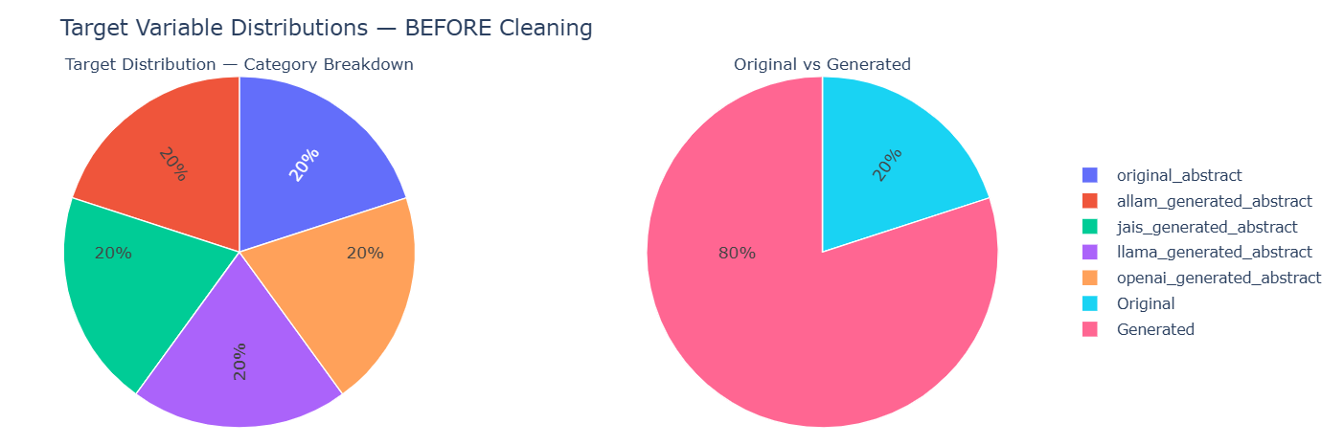
Figure 1.Data distribution before cleaning.
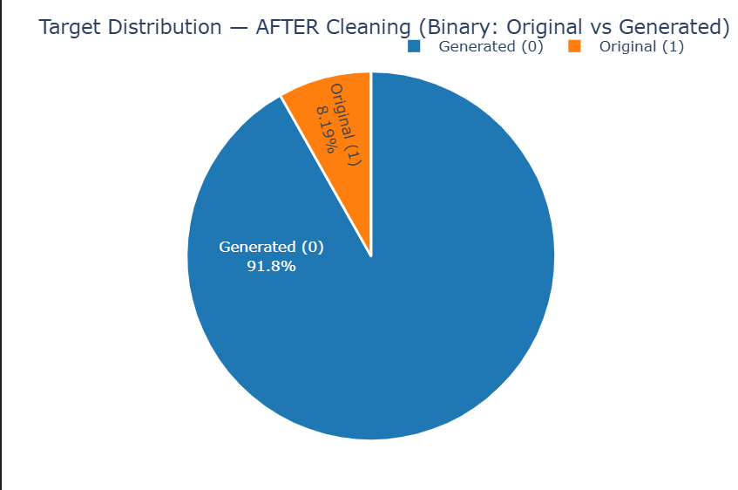
Figure 2.Data distribution after encoding.

Arabic Text Preprocessing
The Arabic text preprocessing stage was divided into two main phases: basic normalization and advanced text cleaning.
In the first phase, normalization was performed by unifying Arabic letter forms (for example, converting أ / إ / آ → ا, ى → ي, and ة → ه), removing diacritics, and deleting non-Arabic symbols and digits. Tokenization was applied and then followed by the removal of common Arabic stopwords by using the NLTK library. Each text was then stemmed using the ISRI stemmer to reduce words to their morphological roots, while a separate lemmatized version was created using the Stanza library to retain grammatical meaning.
In the second phase, additional cleaning operations s were to be introduced in order to remove HTML tags, URLs, email addresses, numbers, and repeated punctuation marks. Character elongation was also normalized, and extra whitespace was eliminated to ensure textual consistency. This stage produced in highly standardized version of the Arabic text that is suitable for feature extraction using both TF-IDF and BERT embedding techniques. The fully processed dataset was then saved as processed_dataset.csv to maintain reproducibility and facilitate subsequent modeling tasks.

Statistical Analysis
The statistical analysis examined key linguistic features that includes average word length, sentence length, and vocabulary richness (Type–Token Ratio). Results showed clear differences between human-written and AI-generated abstracts. AI-generated texts (Allam, Jais, LLaMA, OpenAI) had shorter sentences of about 20–25 words with average word lengths near five characters and moderate lexical diversity (TTR ≈ 0.70–0.79). In contrast, human-written abstracts were much longer (≈79 words per sentence) and slightly richer in vocabulary (TTR = 0.798), reflecting higher linguistic complexity. Overall, human texts appear more diverse and elaborate, while AI-generated ones are concise and uniform, a distinction that supports later model classification.
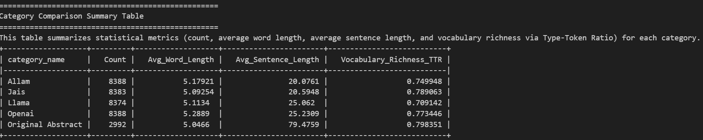
Figure 3.Dataset statical summary.

N-Gram and Word Cloud Analysis
The N-gram analysis was performed to identify the most frequent linguistic patterns in both AI-generated and human-written Arabic abstracts. The results show that AI-generated texts across Allam, Jais, LLaMA, and OpenAI models mainly repeat short academic phrases such as “بحث عن”, “هدف درس”, and “سلط ضوء على”. This where to reflect repetitive and formulaic sentence structures. In contrast, the original human-written abstracts include a wider range of verbs and connectors, indicating more complex and natural language use.
The word cloud visualizations reinforce these findings: The AI-generated groups are dominated by recurring words like “بحث”, “هدف”, and “دراسة”. In contrast, the original abstracts show more of balanced distributions with diverse keywords such as “علم”, “فكر”, and “عمر”. This difference highlights that human writing is more varied and context-rich, whereas AI-generated text tends to rely on frequent template-like expressions.
Figures below present the Top N-grams and Word Clouds for each source (Allam, Jais, LLaMA, OpenAI, and Original Abstract).
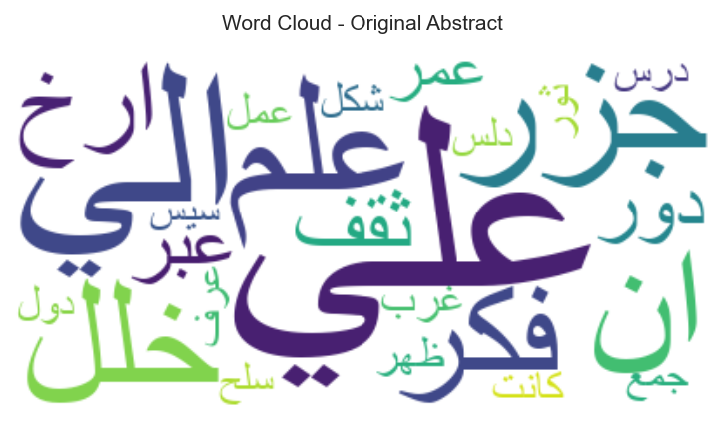  Figure 4.Original worldcloud. | 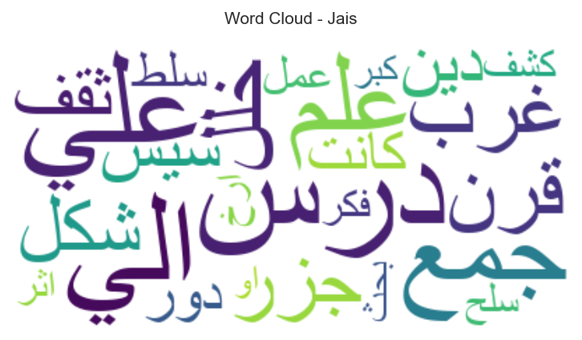  Figure 5.Jais worldcloud. | 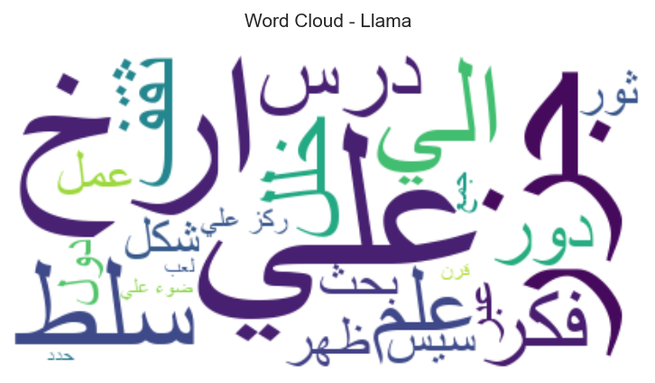  Figure 6.LLaMA worldcloud.
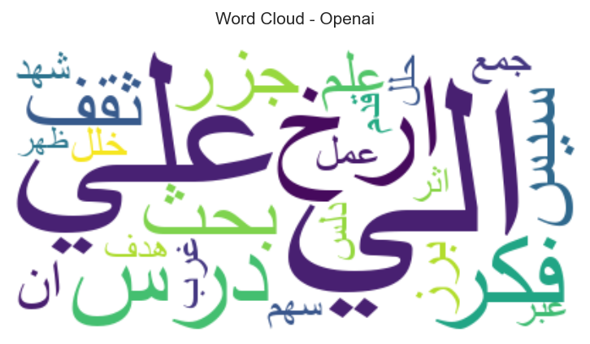  Figure 7.OpenAI worldcloud. | 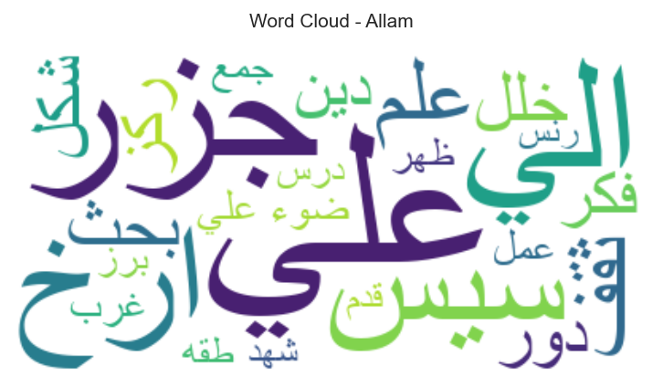  Figure 8.Allam worldcloud.

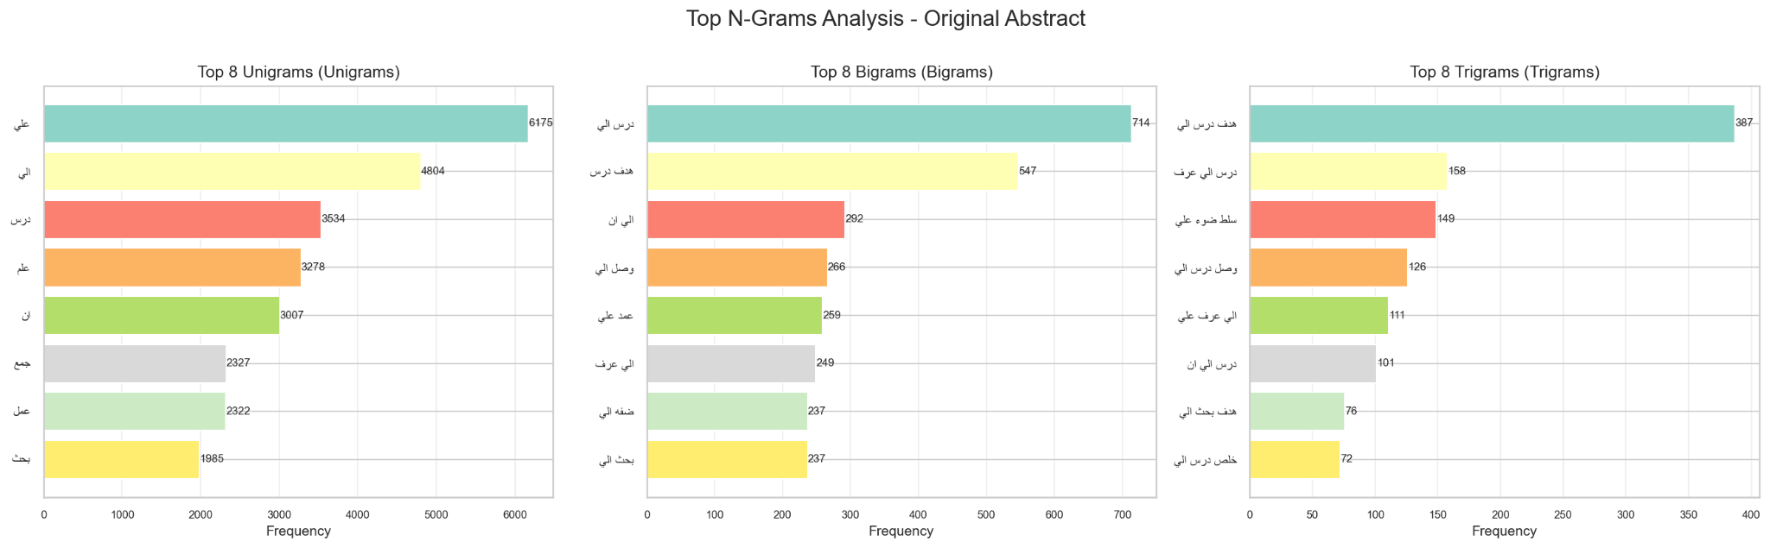
Figure 9.Top N-Grams Analysis-Original Abstract.
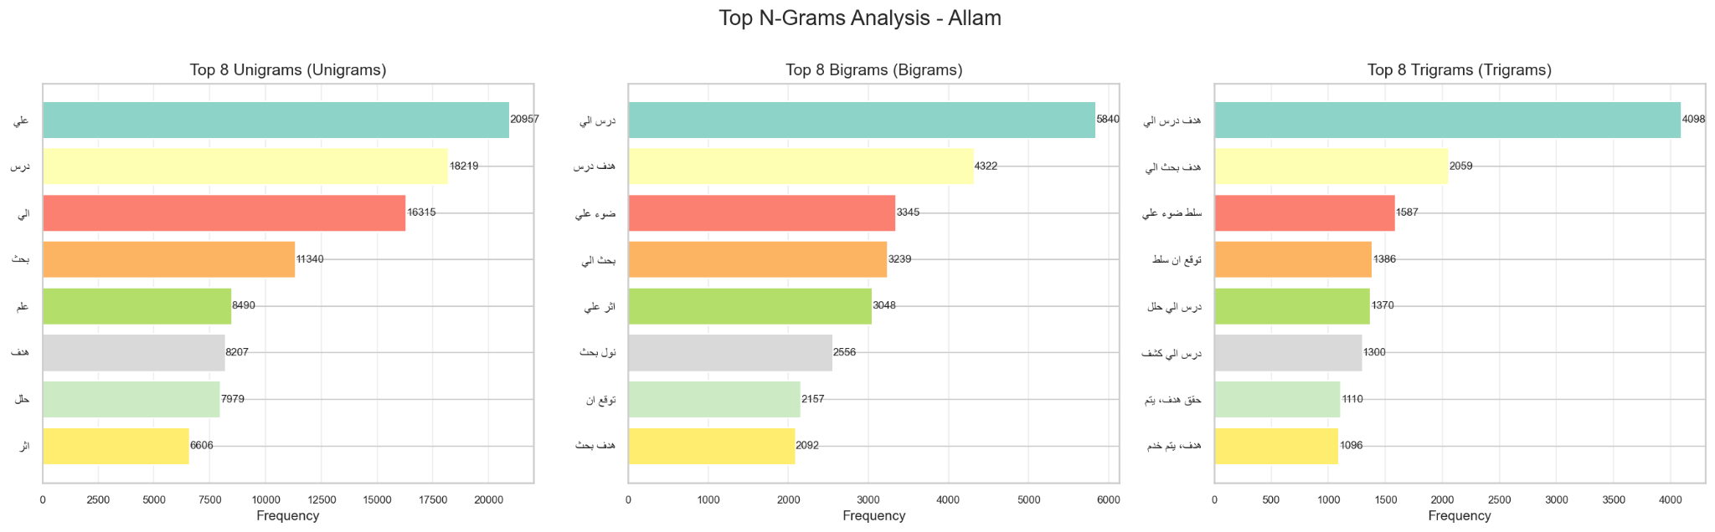
Figure 10.Top N-Grams Analysis-Allam.
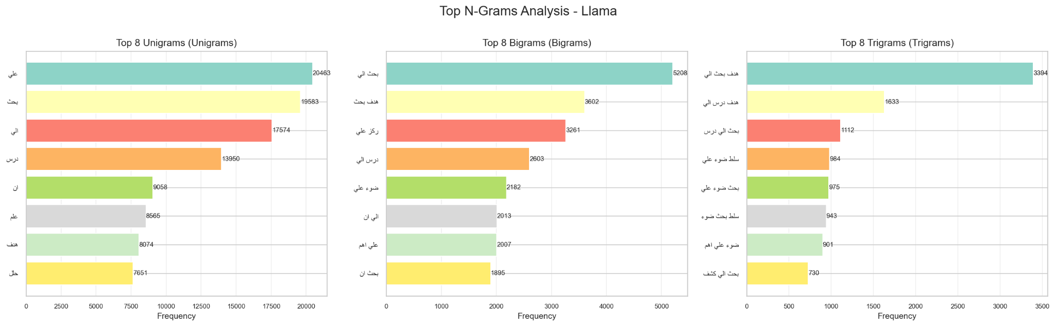
Figure 11.Top N-Grams Analysis-LLaMA.
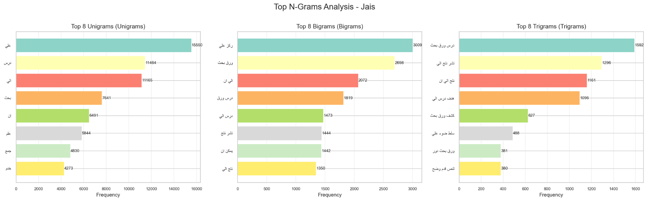
Figure 12.Top N-Grams Analysis-Jais.
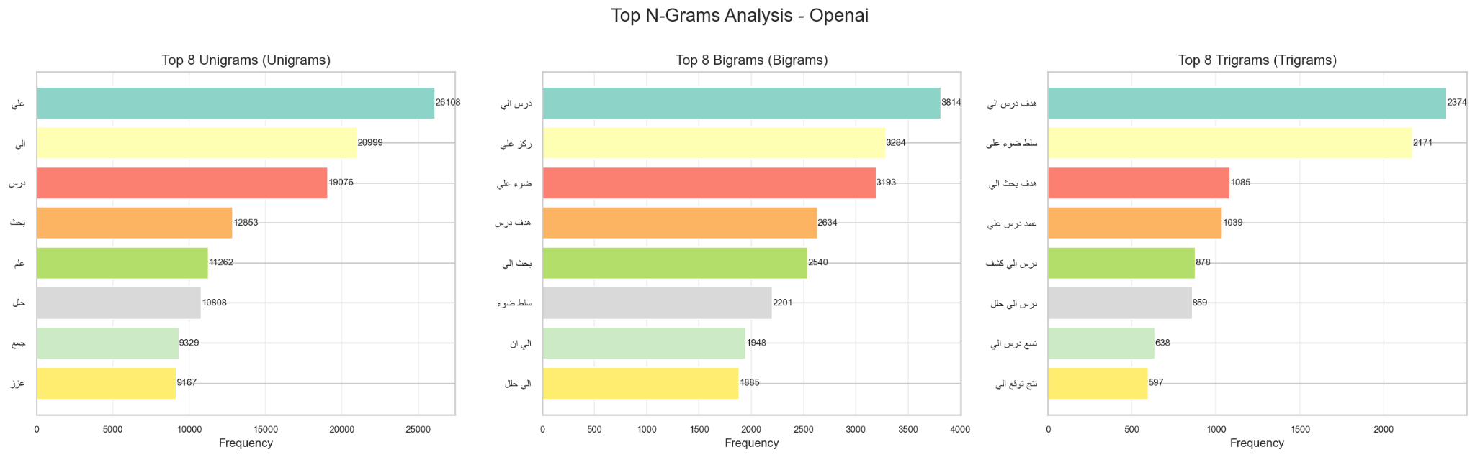
Figure 13.Top N-Grams Analysis-Open-AI.

Lexical Analysis Summary
The lexical analysis examined how function words, punctuation marks, and specific Arabic terms are distributed across both AI-generated and human-written abstracts.
As shown in the summary visualization, OpenAI texts contained the highest number of total words and punctuation marks, while Original Abstracts used fewer overall but with more natural variation. The function word density (around 23–24 words per 1,000 characters) remained relatively stable across all models, however, the punctuation density varied significantly. It peaked in Jais (20.5 per 1,000 chars) and dropping in OpenAI (13.7 per 1,000 chars).
These differences indicate that AI-generated abstracts tend to overuse structural markers (such as “في”, “على”, “إلى”) and punctuation in patterned ways, whereas human-written abstracts employ punctuation and linking words more naturally and contextually. Overall, this reinforces that AI-generated language is more formulaic, while human writing remains more flexible and expressive.
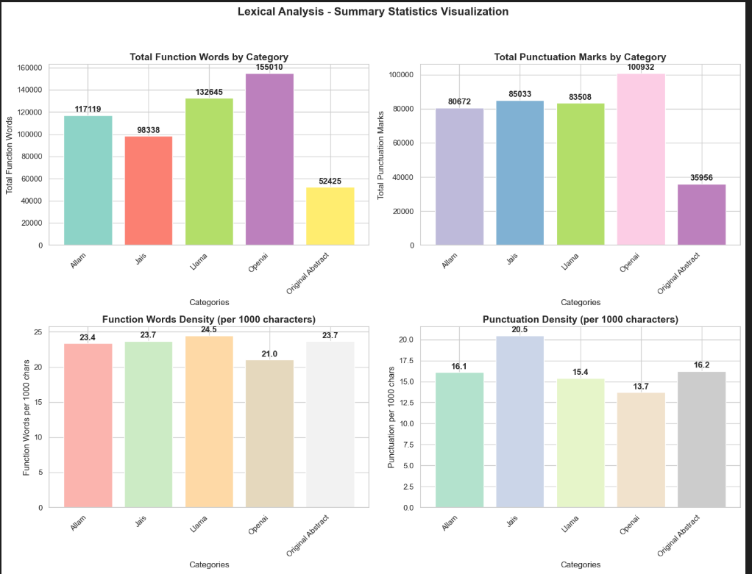
Figure 14.Lexical Analysis summary visualization.

Feature Engineering

Short Words Ratio
The short-word feature measures the proportion of words with three letters or fewer in each abstract. Across the dataset (36,524 samples), the overall average ratio was 0.09, meaning short words made up roughly 9% of total tokens. Category-wise comparison showed that Jais (10.8%) had the highest short-word frequency, followed by Original (9.8%), Allam (9.7%), LLaMA (8.9%), and OpenAI (8.1%). Although differences are small, human-written and Jais-generated texts tend to include more short connective and functional words (e.g., “في”, “من”, “عن”), while OpenAI outputs favor longer, structured terms. This feature captures subtle stylistic and syntactic tendencies valuable for text classification.

Total Number of Lines (L) and Sentence Count
Across 36,524 cleaned texts, each abstract is stored as a single physical line (Average Lines = 1.0), so line count is non-discriminative. In contrast, sentence count varies meaningfully (overall mean = 5.79; total = 211,324 sentences). Human-written abstracts have the highest average sentences (7.43), followed by OpenAI 6.50, Jais 5.91, LLaMA 5.66, and Allam 4.49. Because lines are constant, the line-to-sentence ratio (≈ 1/Avg_Sentences) decreases with richer structure (lowest for Original at 0.13), confirming that human texts are more segmented and syntactically elaborate, while AI outputs—especially Allam—tend to be more concise. This justifies using sentence count (not physical lines) as a useful stylistic feature in downstream models.

Active Voice Sentence Count
Active sentence count varies meaningfully across the dataset (overall mean is 1.43) The low overall mean (1.43) suggests that the writing style across the entire dataset leans more toward the passive voice that outputs default to more neutral or descriptive phrasing (“is shown”, “is performed”). Allam abstracts have the highest average active voice sentences (1.83), followed by Original 1.46, OpenAI 1.32,Jais 1.31, and LLaMA 1.24. Allam and Original show a slightly more active writing style than machine-generated abstracts. This analysis is useful for evaluating the readability and style of the different abstract types, often finding that writing with a higher active voice count is perceived as clearer and more authoritative.

Foreign Letters Ratio
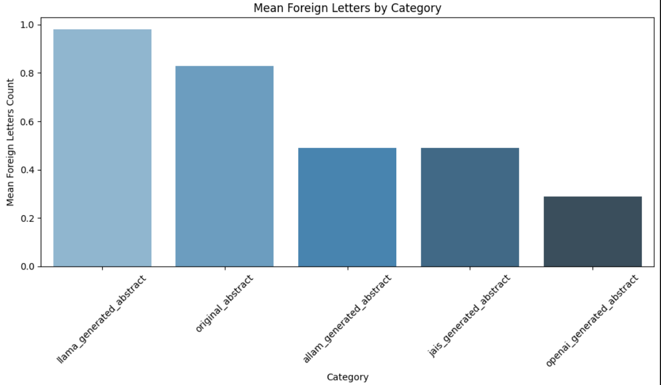
The foreign letter feature measures the presence of non-Arabic characters within each abstract. Across all 36,524 samples, the average count was low (mean = 0.58 letters per text), confirming that the dataset is almost entirely Arabic. However, minor variations were observed between categories: LLaMA (0.98) and Original (0.83) contained slightly higher foreign character frequencies—mainly due to English terms, symbols, or abbreviations, while Allam (0.49), Jais (0.49), and OpenAI (0.29) remained nearly pure Arabic. This indicates that human-written and some LLaMA-generated texts occasionally integrate foreign elements, offering a subtle but useful stylistic cue for model differentiation.
Figure 15.Foreign letters ratio visualization.

Redundancy Score
The redundancy score is founds to measure textual repetition based on TF-IDF similarity within each abstract. The overall mean score was 0.53 which indicates moderate repetition across the corpus. AI-generated texts showed noticeably higher redundancy, Allam (0.56), LLaMA (0.55), Jais (0.54), and OpenAI (0.52) , while human-written abstracts had a much lower average (0.39). This suggests that AI models often reuse similar phrases or structures, whereas human authors write with greater lexical variation and syntactic diversity, making redundancy a strong stylistic discriminator in classification.
Number of texts of Very High Redundancy: 36467
Number of texts of Moderate Redundancy: 0
Number of texts of Low Redundancy: 57

Model Development and Evaluation
The primary objective of this study was to perform Arabic text classification using a variety of traditional and deep learning models under two feature representation techniques: TF-IDF and BERT embeddings.
The experimental results demonstrate that TF-IDF features were highly effective for traditional machine learning algorithms, yielding superior performance in both accuracy and F1-score. For instance, Xgboost achieved an accuracy 95.11% with F1-Score 95.02%. Logistic Regression reached an accuracy of 94.36% and an F1-score of 0.946, while Random Forest reached 93.90% accuracy with an F1-score of 0.933. These models provided robust and interpretable results when applied to sparse lexical representations.
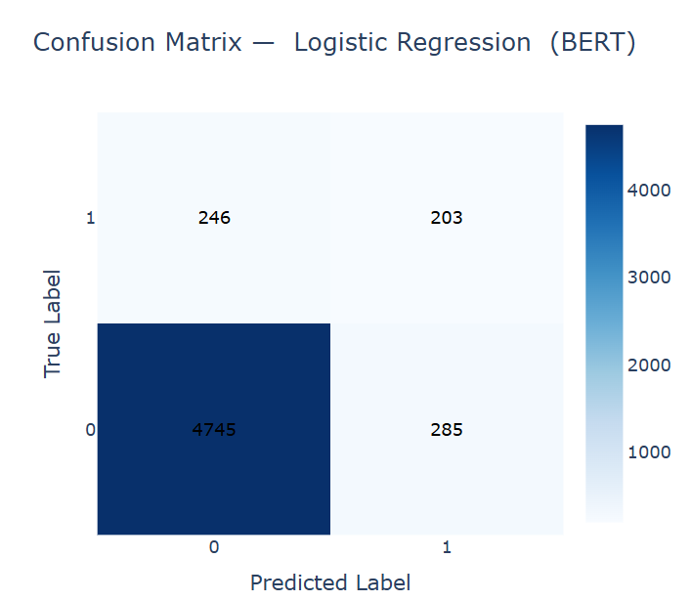
Figure 16.LR with BERT features confusion matrix.
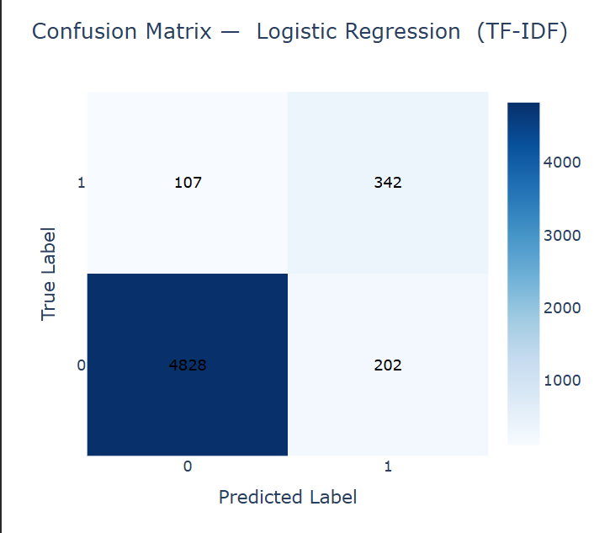
Figure 17.LR with TF-IDF features confusion matrix.

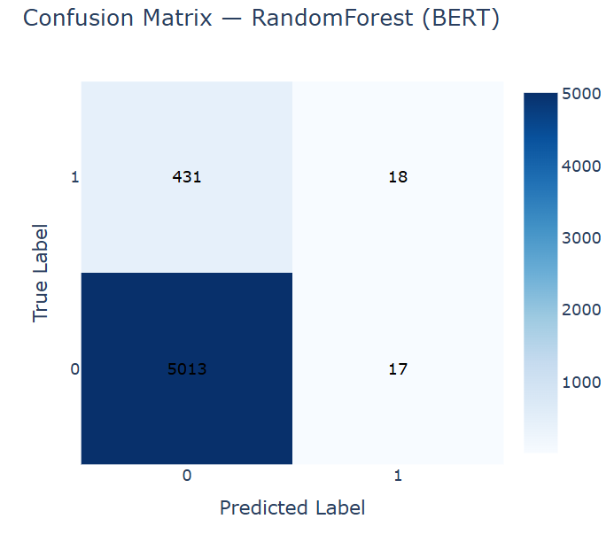
Figure 18. RF with BERT features confusion matrix.
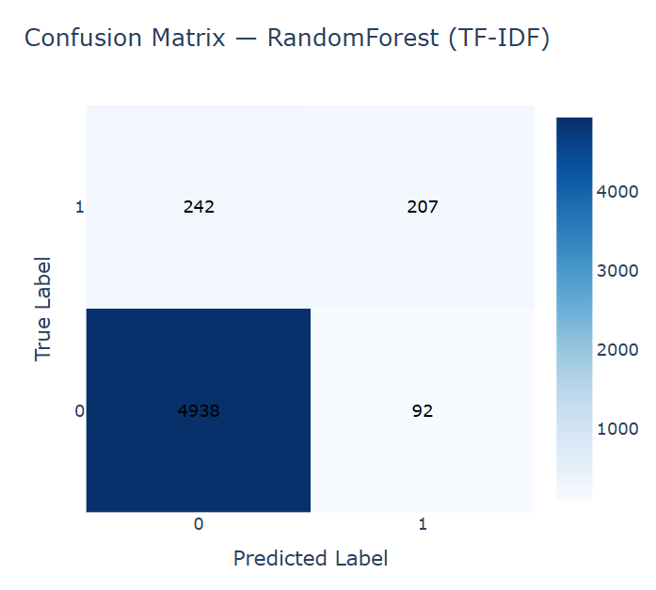
Figure 19. RF with TF-IDF features confusion matrix.
Similarly, the Support Vector Machine (SVM) model performed very competitively, achieving 94.10% accuracy and an F1-score of 0.934 using TF-IDF features. This highlights its robustness in handling high-dimensional text data and its ability to achieve consistent generalization compared to other classical algorithms.
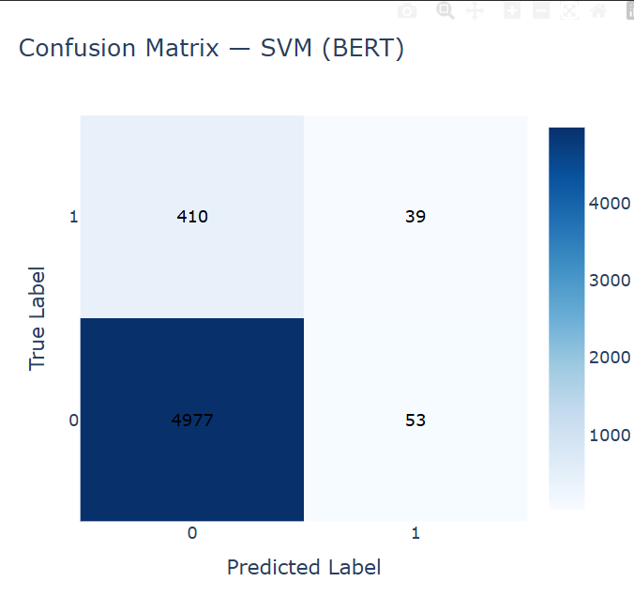
Figure 20. SVM with BERT features confusion matrix.
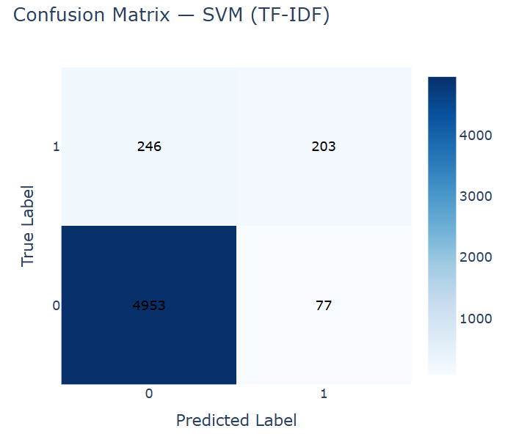
Figure 21. SVM with TF-IDF features confusion matrix.
BERT embeddings exhibited stronger generalization within deep learning architectures, where contextual and semantic understanding contributed to more consistent classification performance. The Feed-Forward Neural Network (FFNN) achieved an accuracy of 92.00%, while the Simple DNN attained 91.29%, confirming the advantage of contextual embeddings for capturing deeper linguistic relationships in Arabic text.
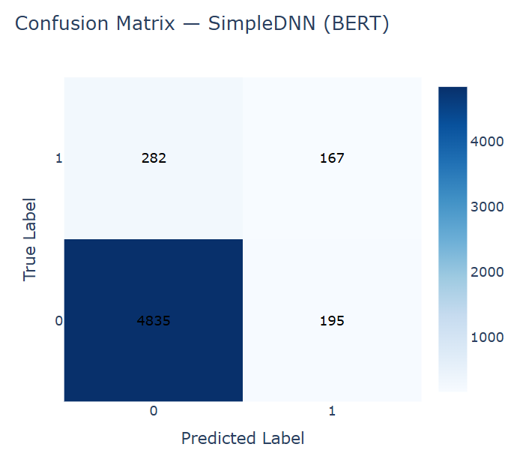
Figure 22.SimpleDNN with BERT features confusion matrix.
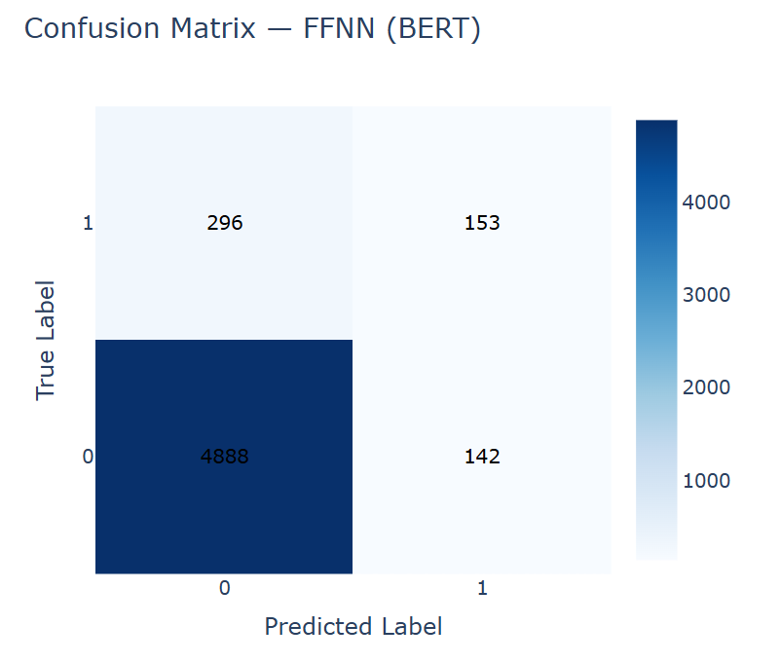
Figure 23.SimpleDNN with TF-IDF features confusion matrix.
The Naïve Bayes model performed relatively poorly with BERT embeddings (Accuracy = 56.85%), due to its independence assumption, but achieved 90.01% accuracy when trained on TF-IDF features, highlighting its compatibility with simpler representations.
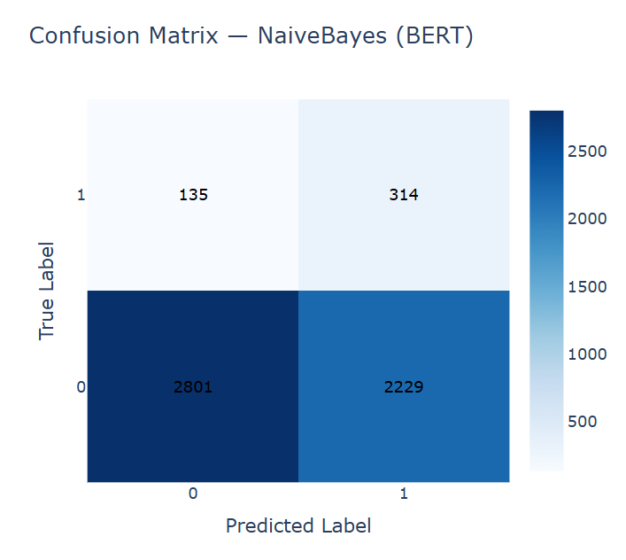
Figure 24. Naïve Bayes with BERT features confusion matrix.
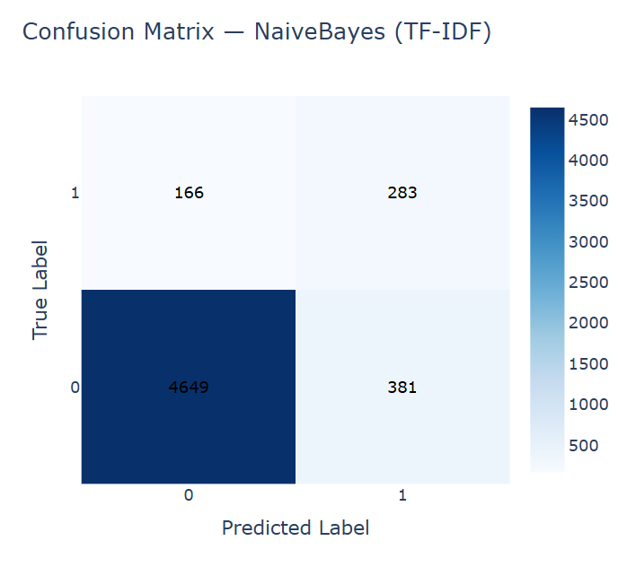
Figure 25.Naïve Bayes with TF-IDF features confusion matrix.
Among all evaluated models, XGBoost using TF-IDF produced the highest overall performance (Accuracy = 95.10%, F1-score = 0.950, ROC-AUC = 0.967), representing an optimal balance between efficiency, interpretability, and predictive power.
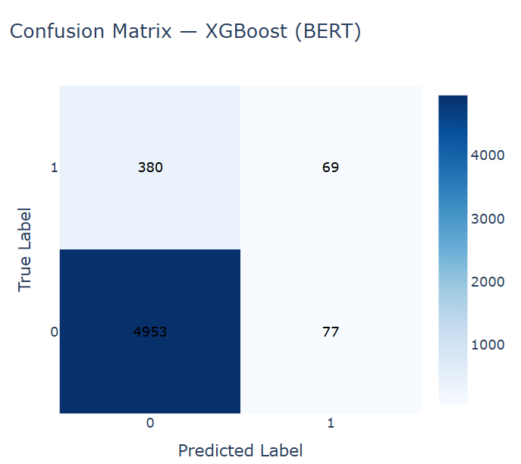
Figure 26.XGBoost with BERT features confusion matrix.
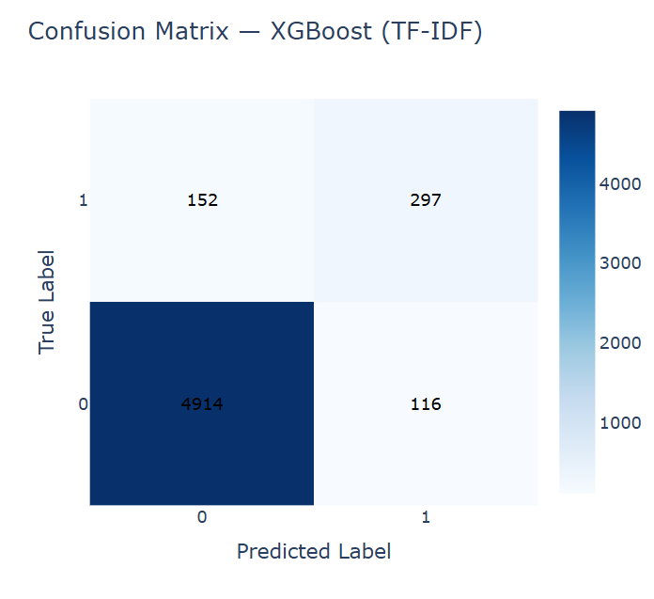
Figure 27.XGBoost with TF-IDF features confusion matrix.
Those findings confirm that TF-IDF representations remain highly suitable for classical models, whereas BERT embeddings are more advantageous for deep learning architectures. These results together provide a comprehensive benchmark for Arabic text classification and emphasize the complementary roles of lexical and contextual feature representations.
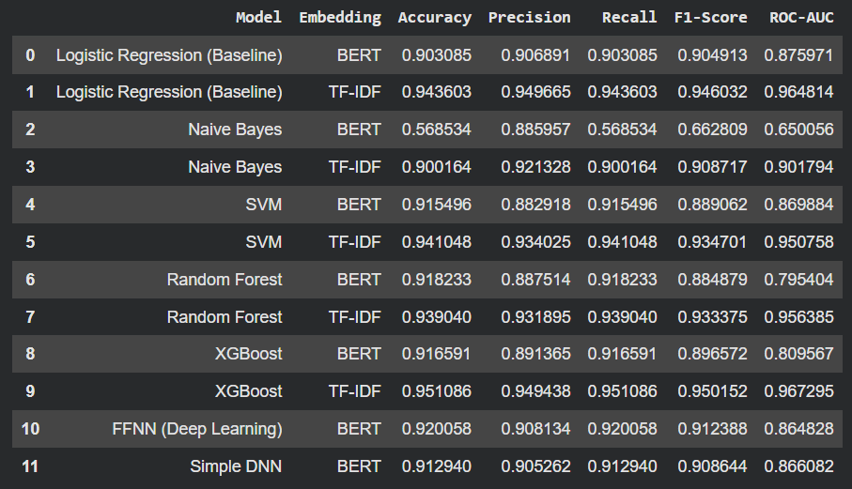
Figure 28.All models evaluation metrics.

Conclusion & Future Work
This study developed an integrated framework for detecting AI-generated Arabic text by combining stylometric and embedding-based approaches. TF-IDF features were very useful for conventional machine learning models, according to comparative experiments. BERT embeddings, on the other hand, improved deep learning models' generalization. Eventually, among all tested algorithms XGBoost with TF-IDF achieved the best overall performance (Accuracy = 95.1%, F1 = 0.950), demonstrating an optimal balance between accuracy, interpretability, and computational efficiency.
The linguistic and statistical analyses confirmed distinct stylistic differences between human-written and AI-generated Arabic texts. The latter is generally shorter, more repetitive and structurally consistent. These findings validate the effectiveness of automated Arabic AI-text detection and highlight its importance for maintaining content integrity in the era of large language models.
For future research, the framework could be expanded to include cross-domain and cross-model evaluations for stronger generalization. Also, it could integrate dialectal and social-media Arabic for broader coverage. Additionally, fine-tuning of transformer-based models to enhance contextual and stylistic discrimination.

References
- Al-Shaibani, M. S., & Ahmed, M. (2025). The Arabic AI fingerprint: Stylometric analysis and detection of large Language Models text. Retrieved from http://arxiv.org/abs/2505.23276
- Boutadjine, A., Harrag, F., & Shaalan, K. (2025). Human vs. Machine: A comparative study on the detection of AI-generated content. ACM Transactions on Asian and Low-Resource Language Information Processing, 24(2), 1–26. doi:10.1145/3708889
- Khairallah, A., & Zubiaga, A. (2025). ALHD: A large-scale and multigenre benchmark dataset for Arabic LLM-generated text detection. doi:10.48550/arXiv.2510.03502

Table Of Figures
Figure 1.Data distribution before cleaning. 6
Figure 2.Data distribution after encoding. 7
Figure 3.Dataset statical summary. 8
Figure 4.Original worldcloud. 9
Figure 5.Jais worldcloud. 9
Figure 6.LLaMA worldcloud. 9
Figure 7.OpenAI worldcloud. 9
Figure 8.Allam worldcloud. 9
Figure 9.Top N-Grams Analysis-Original Abstract. 10
Figure 10.Top N-Grams Analysis-Allam. 10
Figure 11.Top N-Grams Analysis-LLaMA. 10
Figure 12.Top N-Grams Analysis-Jais. 11
Figure 13.Top N-Grams Analysis-Open-AI. 11
Figure 14.Lexical Analysis summary visualization. 12
Figure 15.Foreign letters ratio visualization. 13
Figure 16.LR with BERT features confusion matrix. 14
Figure 17.LR with TF-IDF features confusion matrix. 14
Figure 18. RF with BERT features confusion matrix. 15
Figure 19. RF with TF-IDF features confusion matrix. 15
Figure 20. SVM with BERT features confusion matrix. 15
Figure 21. SVM with TF-IDF features confusion matrix. 16
Figure 22.SimpleDNN with BERT features confusion matrix. 16
Figure 23.SimpleDNN with TF-IDF features confusion matrix. 16
Figure 24. Naïve Bayes with BERT features confusion matrix. 17
Figure 25.Naïve Bayes with TF-IDF features confusion matrix. 17
Figure 26.XGBoost with BERT features confusion matrix. 17
Figure 27.XGBoost with TF-IDF features confusion matrix. 18
Figure 28.All models evaluation metrics. 18

